* Name**: Ali Larian**
* Picture: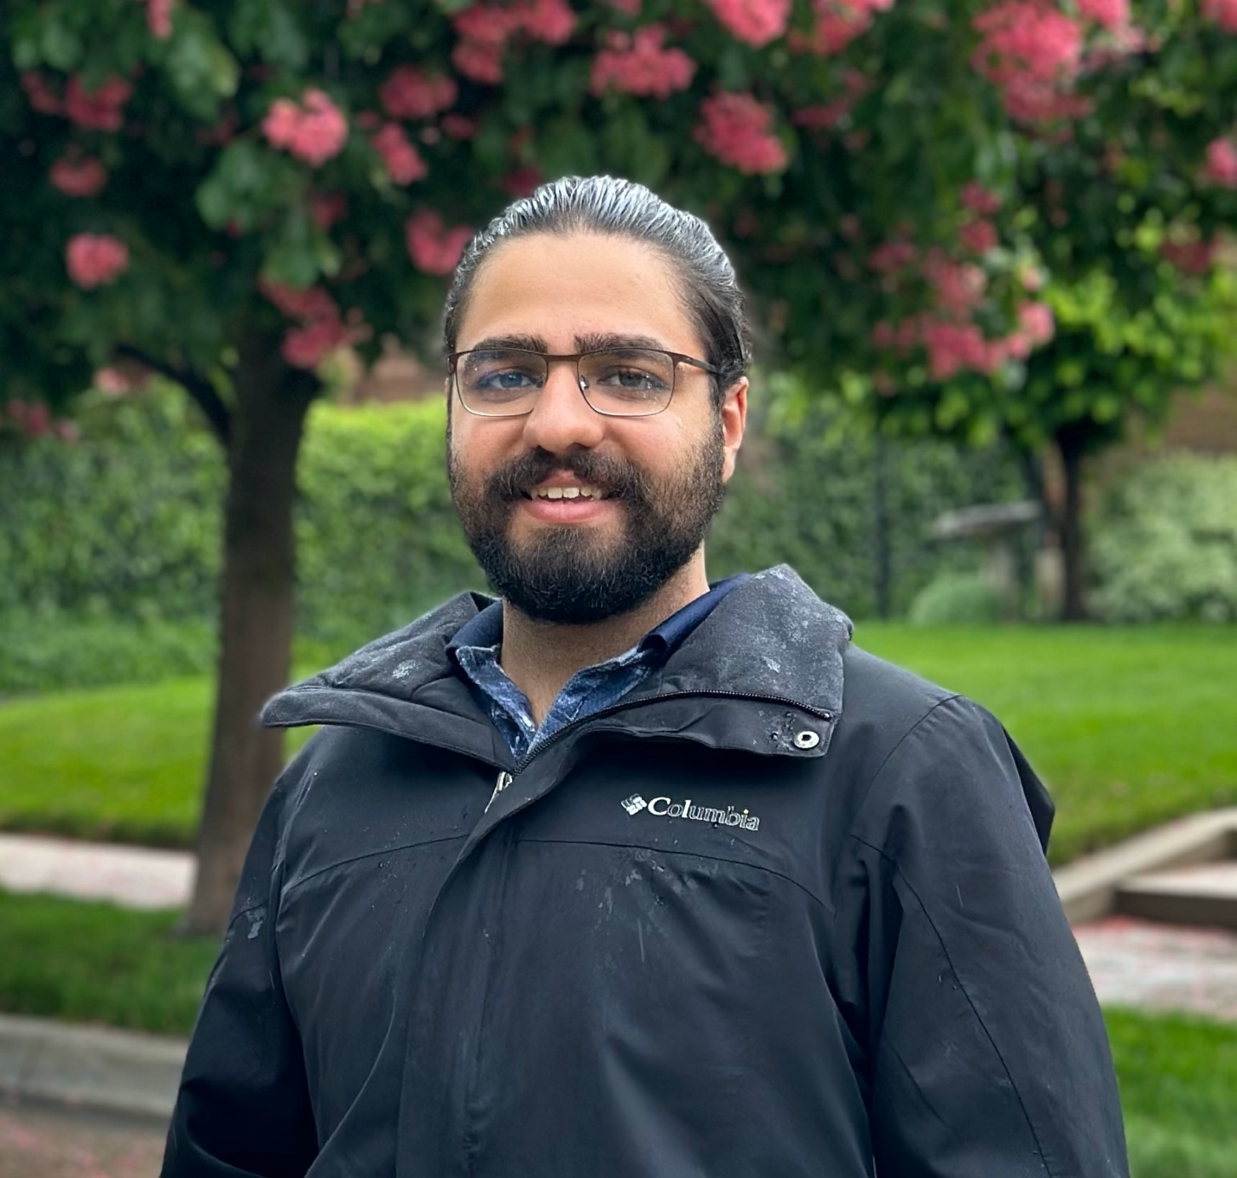
* Degreeand Department: PhD in Computer Science**.**
* About**:**

I am a PhD student at the University of Utah, working under the supervision of Dr. Daniel Brown. My research focuses on designing and implementing models that enable robots to self-assess their performance and operate independently of human supervision, while remaining aligned with human objectives. To achieve this, I use a variety of tools, including Reinforcement Learning (RL), Inverse Reinforcement Learning (IRL), Bayesian IRL, and learning from different types of human feedback.

In my free time, you can find me playing tennis or swimming. I also enjoy reading and discussing topics related to economics.

* Links**:**
  + Personal Website Link:
  + Google Scholar Link:
  + Personal Github Link: https://github.com/Alilarian
  + Other links, if any: https://medium.com/@a.larian